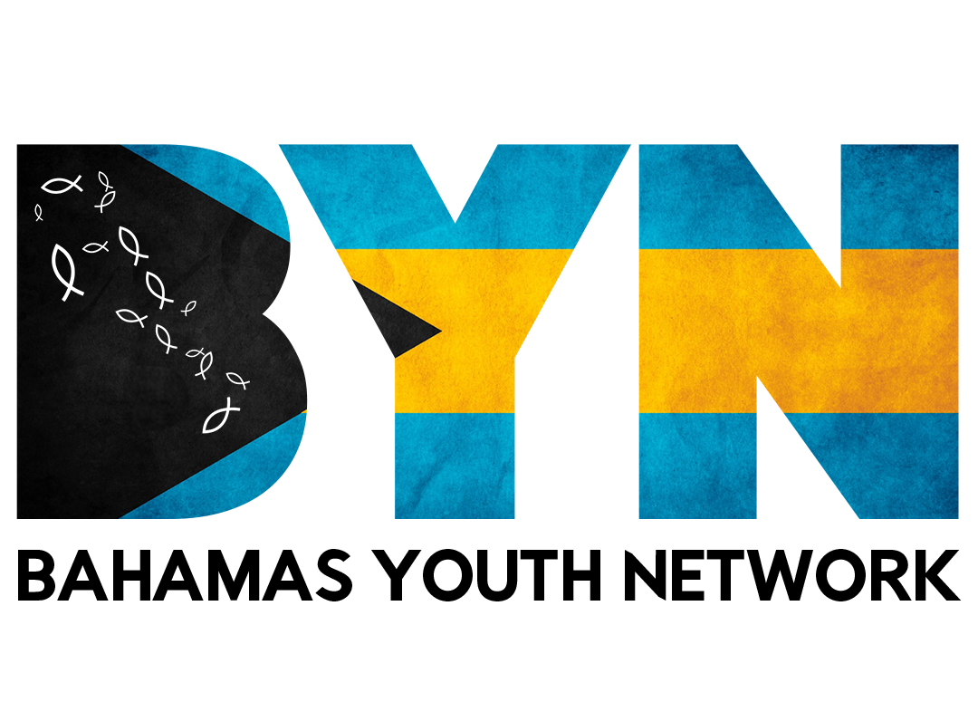
Safe Guarding
BAHAMAS YOUTH NETWORK | TRAINING RESOURCE
“Safeguarding is the action that is taken to promote the welfare of children and protect them from harm.”
Safeguarding and promoting welfare can be defined as:
- Providing help and support to meet the needs of children as soon as problems emerge.
- Protecting children from maltreatment, whether that is inside or outside the home.
Safegaurding Principles  - Be aware that the welfare of the child is paramount.  - Respect all individuals regardless of their age, gender, ethnicity, developmental stage, sexual orientation, religion, belief or whether the individual is disabled.  - Be responsible for your own actions and behavior. Develop your own personal code of conduct that you abide by at all times; this includes dress code, use of language and general behavior. Avoid any conduct which could lead to questions about your motives or intentions.  - Be absolutely clear that you know what to do if you have concerns about a child or a colleague’s behavior.  - In the BYN, be open, accessible, always prepared to listen and supportive of children’s needs.  - You should always be open and honest when dealing with children and young people, so nothing can be misinterpreted. | Safe Practices  - Do not engage in private, none BYN ministry related email, text or telephone conversations with young people. Social media interactions should always be in a public forum or group.  - Do not accept personal or ‘friend requests’ on social networking sites. Ensure that your social media profiles are set to private.  - Do not accept gifts unless they are small tokens of appreciation.  - Do not offer rides to young people outside the agreements of your position. Never be alone with a minor of the opposite sex/gender in a vehicle.  - Follow the BYN’s policy and procedures with regard to physical intervention or contact. No corporal punishment.  - There should be no photography or filming of children that is not for clear BYN purposes.  - You should report to your ministry director if a child or young person has become infatuated with you.  - You should report your ministry director if a child or parent has become dependent on you
Medium-Level Concerns  A ‘Medium-level’ concern (one that does not meet the harm threshold) does not mean it is insignificant. It is any concern — no matter how small — that an adult working in or on behalf of the organization may have acted in a way that:  - Is inconsistent with the staff code of conduct, including inappropriate conduct outside of the organization.  - Does not meet the harm threshold, or is otherwise not serious enough to warrant a referral under the safeguarding policy. | Examples- ‘Medium-Level’ Concern  - Being over-friendly with children or young people  - Showing favoritism.  - Taking photographs of a young person on your mobile phone not for clear BYN sharing purposes.  - Engaging with a young person on a one-to-one basis in a secluded area or behind a closed door.  - Humiliating a young person
Source: adapted from Tes – Child Protection for International Schools, Module 5: Promoting Good Practice.

!!!Report ALL safeguarding concerns/violations to your ministry director immediately!!!

